CS 430: ARTIFICIAL INTELLIGENCE

PROJECT 2 – PACMAN

Prof. Grissom

October 15, 2018

Gregory Montilla

1. Finding all the corners
   1. tinyCorners  
      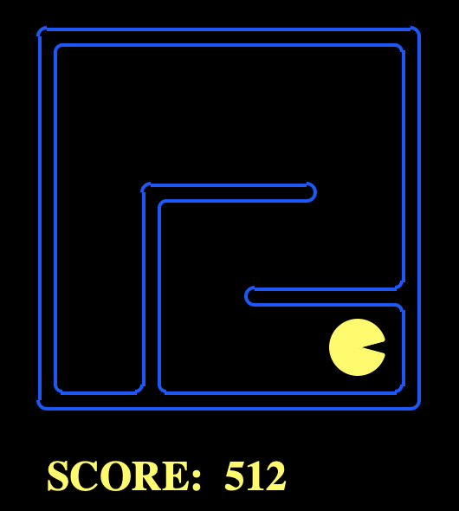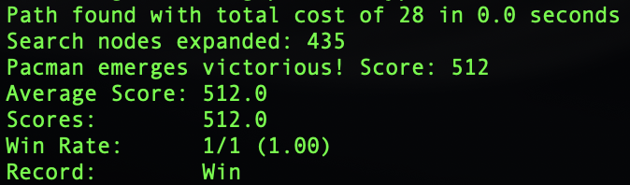
   2. mediumCorners  
      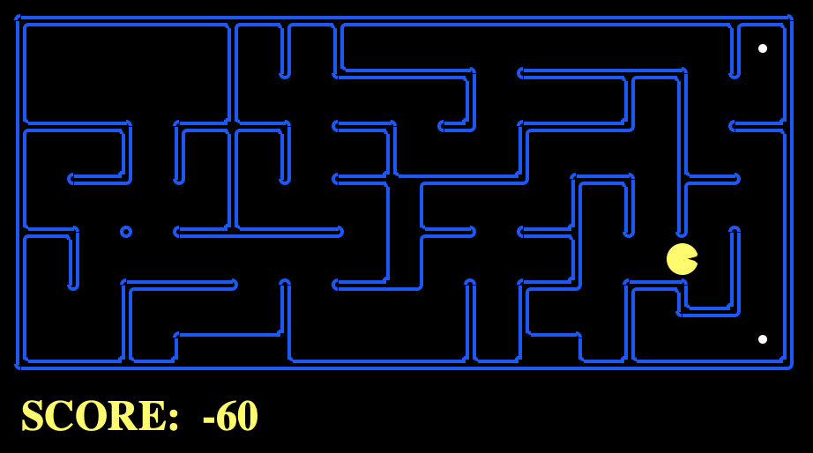

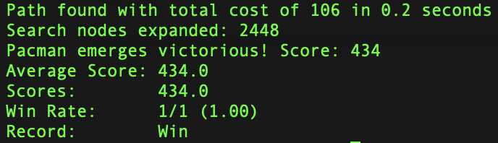

* 1. bigCorners  
     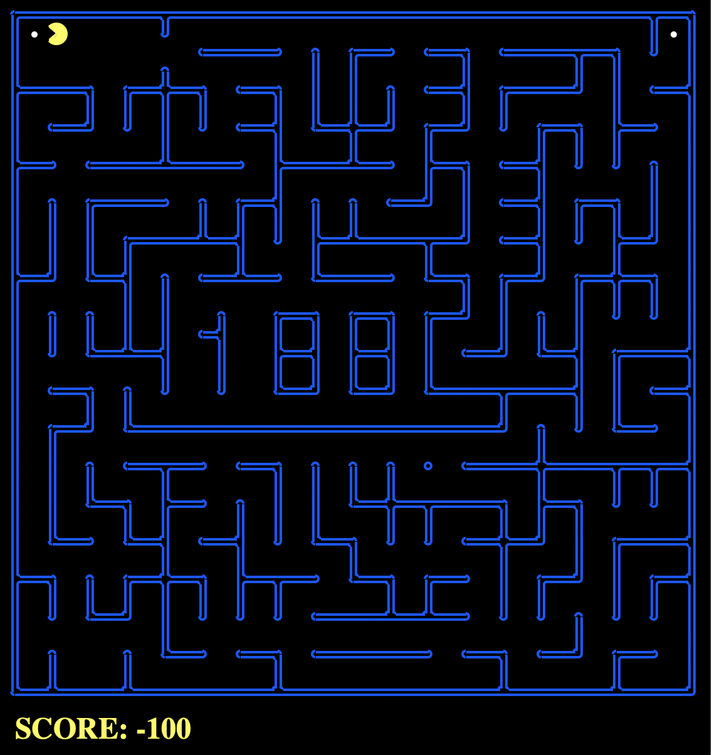  
     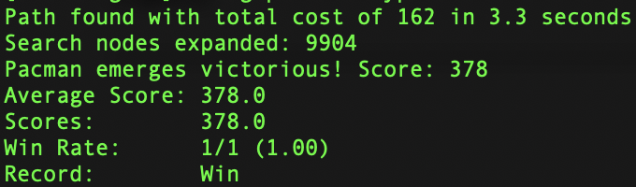

1. Corners Problem: A* Heuristic
   1. tinyMaze  
      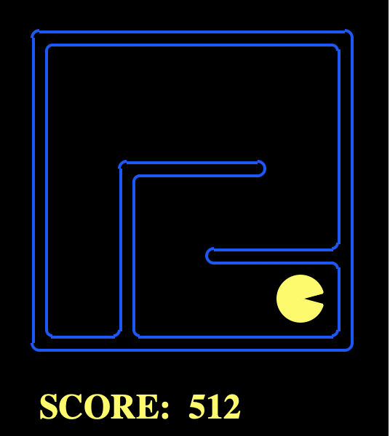  
      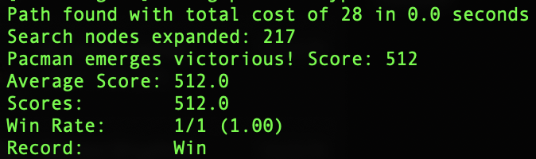
   2. mediumMaze  
      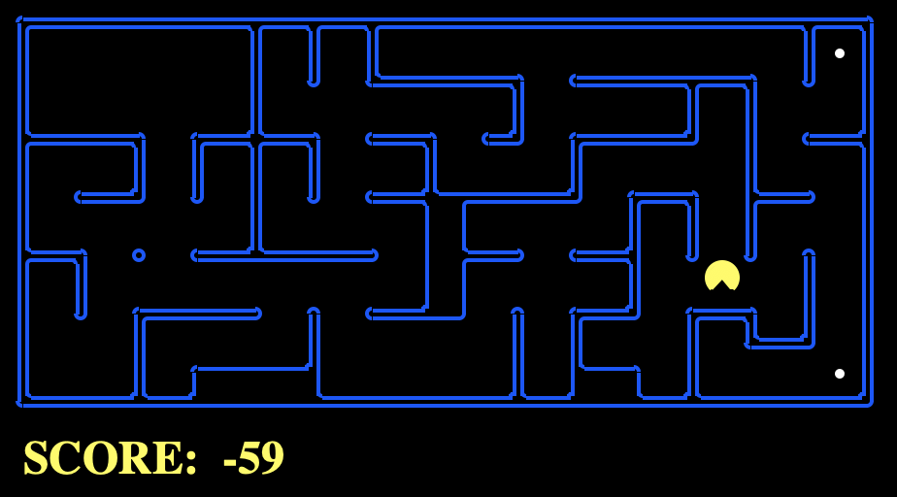  
      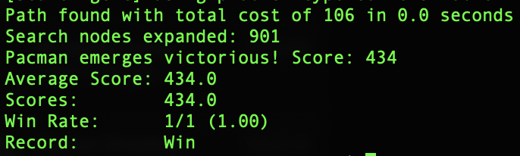
   3. bigMaze  
      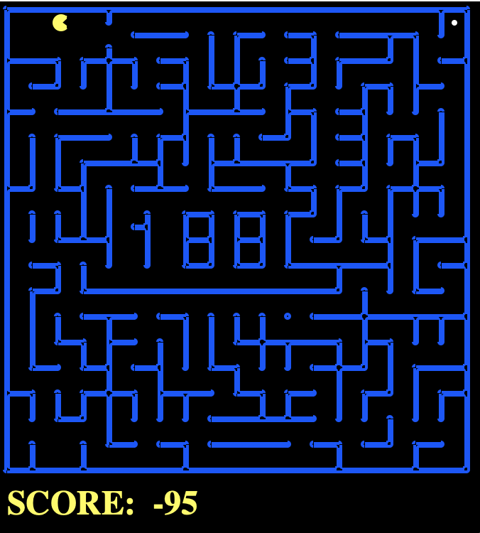  
      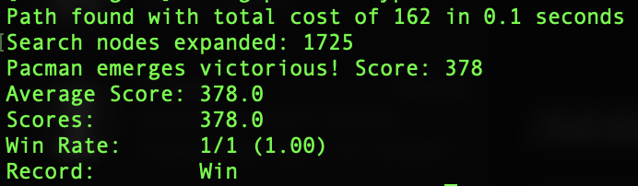

SUMMARY CHART

|  |  |  |  |  |
| --- | --- | --- | --- | --- |
| **Algorithm** | **Maze** | **Execution Time** | **Time Complexity** | **Score** |
| BFS | tinyMaze | 0.0 | 435 | 512 |
| mediumMaze | 0.2 | 2448 | 434 |
| bigMaze | 3.3 | 9904 | 378 |
| A* | tinyMaze | 0.0 | 217 | 512 |
| mediumMaze | 0.0 | 901 | 434 |
| bigMaze | 0.1 | 1725 | 378 |